Purpose: Day 13 Classwork and Assignment
Date: 08/01/2026
Author: Vinayak Majhi
ID: 58618
Batch ID: 25SUB4505 - DATACOM+5G

ClassWork

Q.1. Hello World
Create a program that creates a single thread.
Prints "Hello world from thread"
Prints "Hello world from main"
using
std::thread
join()

// Purpose: Create a single thread and print messages from thread and main
// Date: 08/01/2026
// Author: Vinayak Majhi
// ID: 58618
// Batch ID: 25SUB4505 - DATACOM+5G

#include <iostream>
#include <thread>
using namespace std;

void threadFunc() { cout << "Hello world from thread" << endl; }

int main() {
thread t(threadFunc);
t.join();
cout << "Hello world from main" << endl;
return 0;
}

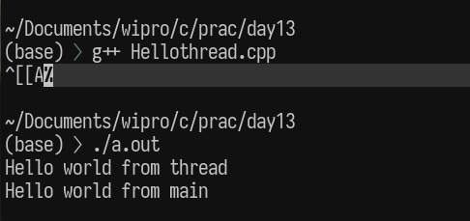

Q 2. get_id() --> Printing ID of the thread.
Create 3 threads so that they can
print its own thread ID using
std::this_thread::get_id()

// Purpose: Create 3 threads and print their thread IDs
// Date: 08/01/2026
// Author: Vinayak Majhi
// ID: 58618
// Batch ID: 25SUB4505 - DATACOM+5G

#include <iostream>
#include <thread>
using namespace std;

void printID() {
cout << "Thread ID: " << this_thread::get_id() << endl;
}

int main() {
thread t1(printID);
thread t2(printID);
thread t3(printID);

t1.join();
t2.join();
t3.join();

return 0;
}

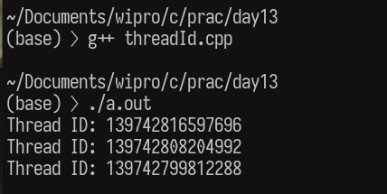

Q 3. Print 1 to 10
a. passing function as argument
b. passing lambda as argument
a. passing function as argument

// Purpose: Print numbers from 1 to 10 using function argument in thread
// Date: 08/01/2026
// Author: Vinayak Majhi
// ID: 58618
// Batch ID: 25SUB4505 - DATACOM+5G

#include <iostream>
#include <thread>
using namespace std;

void printNumbers() {
for (int i = 1; i <= 10; i++)
cout << i << " ";
cout << endl;
}

int main() {
thread t(printNumbers);
t.join();
return 0;
}

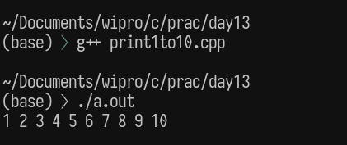

b. passing lambda as argument

// Purpose: Print numbers from 1 to 10 using lambda in thread
// Date: 08/01/2026
// Author: Vinayak Majhi
// ID: 58618
// Batch ID: 25SUB4505 - DATACOM+5G

#include <iostream>
#include <thread>
using namespace std;

int main() {
thread t([]() {
for (int i = 1; i <= 10; i++)
cout << i << " ";
cout << endl;
});

t.join();
return 0;
}

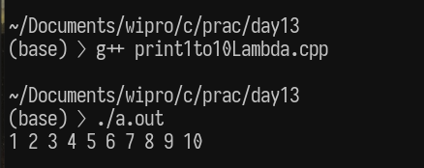
Q.4 join & detach
Create 2 threads
one thread is joined
one thread is detached
task:
print "hello world" to show execution order
Experiment:
What happens if main() exits first.

// Purpose: Demonstrate join and detach behavior in threads
// Date: 08/01/2026
// Author: Vinayak Majhi
// ID: 58618
// Batch ID: 25SUB4505 - DATACOM+5G

#include <chrono>
#include <iostream>
#include <thread>
using namespace std;

void printMessage() { cout << "Hello world from thread" << endl; }

int main() {
thread t1(printMessage);
thread t2(printMessage);

t1.join();
t2.detach();

cout << "Hello world from main" << endl;

this_thread::sleep_for(chrono::seconds(1));
return 0;
}

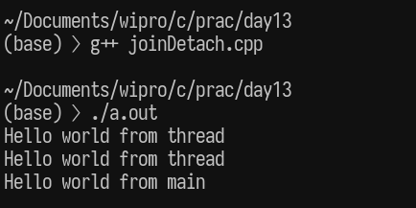

Q.5 Create 5 threads using vector to store thread objects. synchronize with main using join() with all 5 threads

// Purpose: Create multiple threads using vector and synchronize with join
// Date: 08/01/2026
// Author: Vinayak Majhi
// ID: 58618
// Batch ID: 25SUB4505 - DATACOM+5G

#include <iostream>
#include <thread>
#include <vector>
using namespace std;

void task(int id) { cout << "Hello world from thread " << id << endl; }

int main() {
vector<thread> threads;

for (int i = 1; i <= 5; i++)
threads.emplace_back(task, i);

for (auto &t : threads)
t.join();

cout << "All threads finished execution" << endl;
return 0;
}

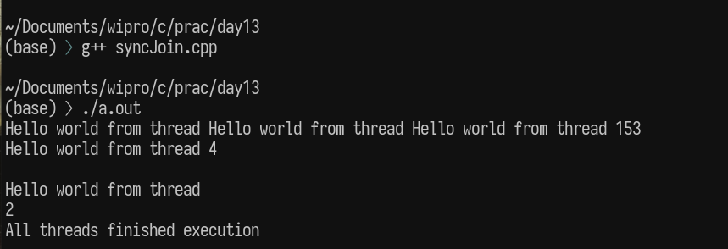

Q. 6. Create an array of 100 elements(global or static array), create 5 threads from main, fill the array elements where each thread fills 20 elements only.

// Purpose: Fill a global array of 100 elements using 5 threads (20 elements per thread)
// Date: 08/01/2026
// Author: Vinayak Majhi
// ID: 58618
// Batch ID: 25SUB4505 - DATACOM+5G

#include <iostream>
#include <thread>
using namespace std;

int arr[100]; // Global array of size 100

void fillArray(int startIndex, int count) {
for (int i = startIndex; i < startIndex + count; i++) {
arr[i] = i + 1;
}
}

int main() {
thread t1(fillArray, 0, 20); // Thread 0 → index 0–19
thread t2(fillArray, 20, 20); // Thread 1 → index 20–39
thread t3(fillArray, 40, 20); // Thread 2 → index 40–59
thread t4(fillArray, 60, 20); // Thread 3 → index 60–79
thread t5(fillArray, 80, 20); // Thread 4 → index 80–99

t1.join();
t2.join();
t3.join();
t4.join();
t5.join();

// Display array contents
for (int i = 0; i < 100; i++) {
cout << arr[i] << " ";
}
cout << endl;

return 0;
}

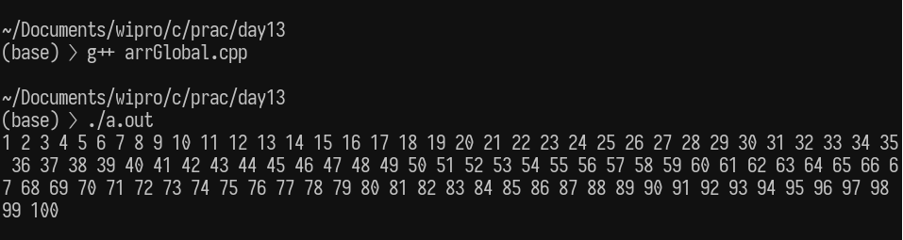
Q.

